Ideation Phase
Empathize & Discover

Date | 25 October 2026
Team ID
Project Name | StaffSync
Maximum Marks | 4 Marks

Empathy Map Canvas:
Understand the needs, frustrations, and behaviors of employees, managers, and HR personnel interacting with the StaffSync Human Resource Management application 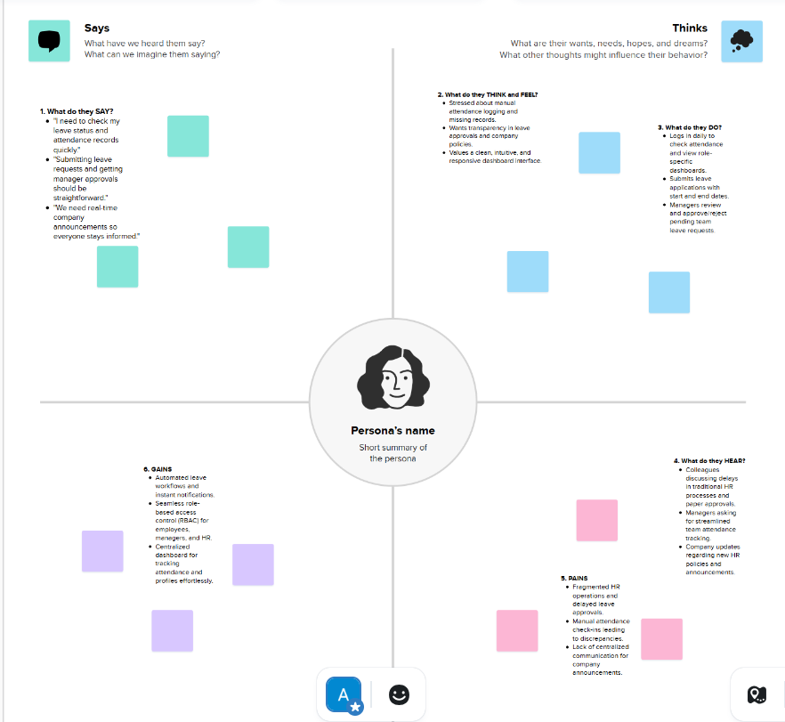

Reference: https://www.mural.co/templates/empathy-map-canvas

